The software we are planning to use is:

* Fritzing
* OpenCV People Counter
* Arduino CC
* Mission Planner
* Librepilot

**Fritzing:**

Fritzing is an open-source initiative to develop amateur or hobby CAD software for the design of electronics hardware. We can in convenience and simply design our circuit diagram using fritzing software with sensors.

**OpenCV People Counter:**

OpenCV is the huge open-source library for computer vision, machine learning, and image processing. We used it for our project as our project has a real-time data collection section and this will help in then. By using it, one can process images and videos to identify objects and faces as in our multifunctional drone we have added a feature to count the number of people who might be present in the designated location we are surveying for better knowledge of the surrounding.

**Arduino CC:**

Arduino is an open-source electronics platform based on easy-to-use hardware and software Arduino boards are able to read inputs and turn it into an output. Applications such as it can read input (light input) on a sensor and activate on an LED or input (a message) and publish that online (as output). In our project for drone’s sensor calibration we have used it.it takes in data.

Advantages:

• Really open source software and hardware both

• Easy to learn

• Huge community

**Mission Planner:**

Mission Planner is a full-featured ground station application for the ArduPilot open source autopilot project. It provides setup and flying support, as well as reviewing recorder flights. It is used in as for Plane, Copter and Rover. It is compatible with Windows only. Mission Planner can be used as a configuration utility or as a dynamic control supplement for your autonomous vehicle

APPLICATIONS:

* Load the [firmware](https://ardupilot.org/planner/docs/common-glossary.html#common-glossary) (the software) into the autopilot board (i.e. Pixhawk series) that controls your vehicle.
* Setup, configure, and tune your vehicle for optimum performance.
* Plan, save and load autonomous missions into you autopilot with simple point-and-click way-point entry on Google or other maps.
* Download and analyze mission logs created by your autopilot.
* Interface with a PC flight simulator to create a full hardware-in-the-loop UAV simulator.
* With appropriate telemetry hardware you can:
  + Monitor your vehicle’s status while in operation.
  + Record telemetry logs which contain much more information the the on-board autopilot logs.
  + View and analyze the telemetry logs.
  + Operate your vehicle in FPV (first person view)
  + 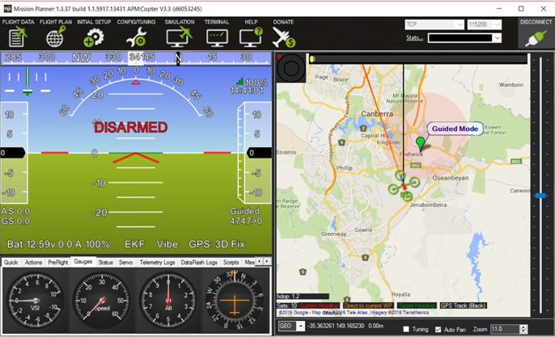

**Librepilot:**

LibrePilot is free software for UAV(Unmanned Aerial vehicle) project for model aircraft aimed at supporting both multi-rotor craft as well as fixed-wing aircraft. It is written in C/C++. We used this for calibrating our drone with the controller. Also known as the OpenPilot , it can be combined with hardware such as an inertial navigation system board, a main control board, a GPS receiver, and a 2.4 GHz serial communications link with the ground station